**Module 4 – Test driven development and Logging framework**

**JUnit Testing Exercises**

**Exercise 4: Arrange-Act-Assert (AAA) Pattern, Test Fixtures, Setup and Teardown Methods in Junit**

**Aim:**

To organize tests using the Arrange-Act-Assert (AAA) pattern and use setup and teardown methods.

**Arrange-Act-Assert (AAA) Pattern**  
A clean way to write test methods:

* **Arrange**: Prepare objects and set up preconditions.
* **Act**: Call the method you want to test.
* **Assert**: Check that the expected result matches the actual result.

**@Before and @After Annotations**

* @Before: Code here runs **before every test** (setup).
* @After: Code here runs **after every test** (teardown).

**Structure:**

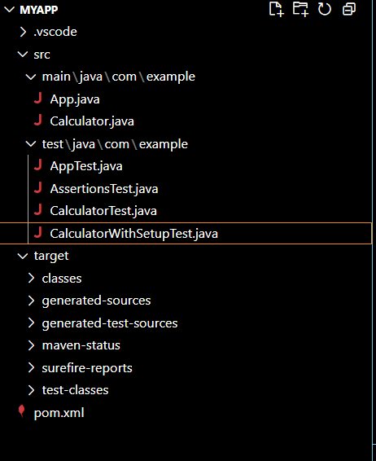

**CalculatorWithSetupTest.java:**

package com.example;

import org.junit.Before;

import org.junit.After;

import org.junit.Test;

import static org.junit.Assert.*;

public class CalculatorWithSetupTest {

    private Calculator calculator;

    // This method runs BEFORE each test

    @Before

    public void setUp() {

        calculator = new Calculator();

        System.out.println("Setup done.");

    }

    // This method runs AFTER each test

    @After

    public void tearDown() {

        calculator = null;

        System.out.println("Teardown done.");

    }

    @Test

    public void testAdd() {

        // Arrange

        int a = 2;

        int b = 3;

        // Act

        int result = calculator.add(a, b);

        // Assert

        assertEquals(5, result);

    }

    @Test

    public void testAddNegativeNumbers() {

        // Arrange

        int a = -5;

        int b = -10;

        // Act

        int result = calculator.add(a, b);

        // Assert

        assertEquals(-15, result);

    }

}

**Output:**

